1. Draw a labeled diagram of an ATX motherboard and mark at least 8 different slots and ports (such as RAM slots, PCIe slots, SATA ports, USB headers, CPU socket, power connector, etc.).
Answer:-
ATX MOTHERBOARD DIAGRAM

RAM SLOTS
CPU SLOTS

8-PIN CPU POWER

24-PIN ATX POWER CONNECTOR

PCIe x16 SLOT

PCIe x1 SLOT

PCIe x1 SLOT

CMOS BATTERY

SATA PORT

M.2 SLOT

USB INTERNAL HEADER

FRONT PANEL HEADER

REAR I/O PORT
LAN DP
USB HDMI
AUDIO USB
2. Research and list 3 popular CPU socket types (for example: LGA1151, AM4, LGA1200) and name one compatible CPU model for each.
Answer:-

Here are 3 popular CPU socket types and an example of a compatible CPU for each:

CPU Socket Type | Manufacturer | Compatible CPU Example
LGA1151 | Intel | Intel Core i7-9700K
AM4 | AMD | AMD Ryzen 5 5600
LGA1200 | Intel | Intel Core i5-10400

LGA1151: Used by several Intel 6th–9th generation desktop CPUs. The Core i7-9700K is an example of an LGA1151-compatible processor.
AM4: AMD's AM4 socket supports many Ryzen processors, including the Ryzen 5 5600.
LGA1200: Used for Intel 10th- and 11th-generation desktop processors. The Core i5-10400 officially supports FCLGA1200.

3. Explain in your own words the primary functions of the CPU and the chipset on a motherboard, and describe how they work together when you open a music app like Spotify.
Answer:-
CPU: The CPU is the main processor of the computer. It executes instructions and performs calculations needed to run programs. When you open Spotify, the CPU processes the app’s instructions, manages tasks, and helps control playback.
Chipset: The chipset manages communication between the CPU and other hardware components, such as RAM, storage, USB devices, and audio devices. When Spotify starts, the chipset helps move data between these components so the CPU can access the app and send audio data to the sound system.

4. Find a clear photo of a real motherboard (from the internet or your own device), and identify at least 5 different ports or slots by circling them and labeling each one.

Answer:-
PORT

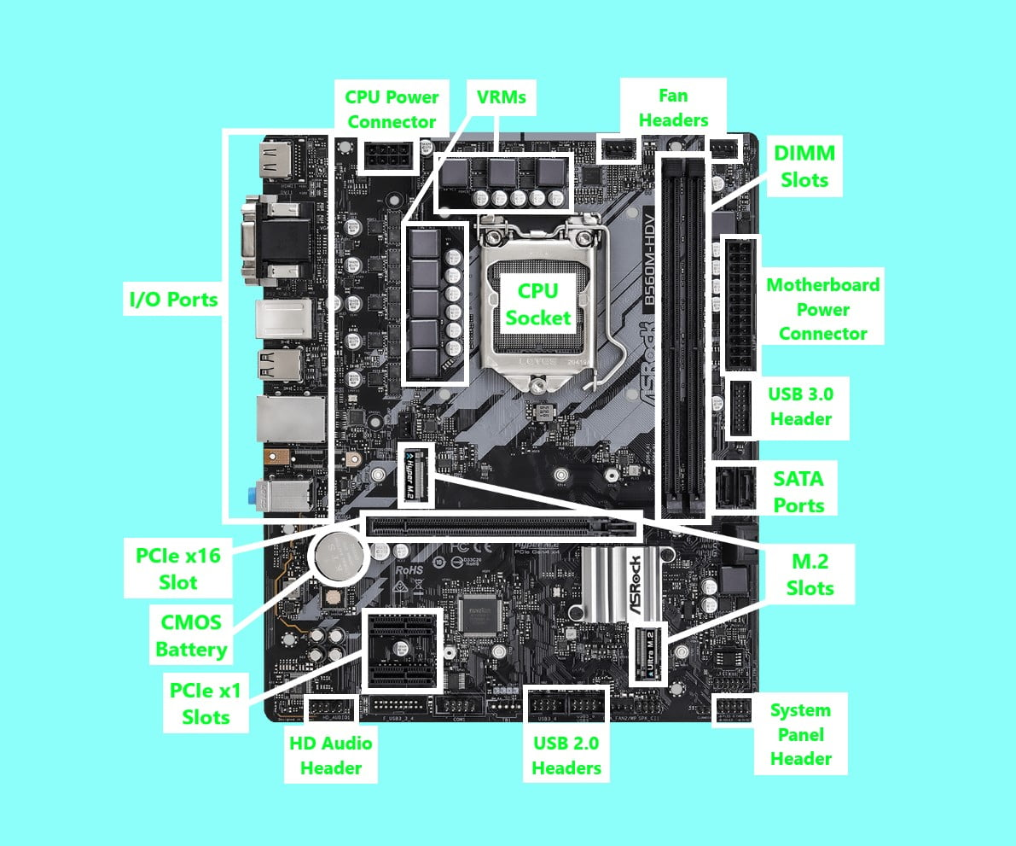

SLOT

